PVC Indoor Garden Light

Make this inexpensive grow light so that you can start seedlings inside in the spring, or grow lettuce and herbs indoors year-round. Because the pieces are not glued, the parts can be disassembled for storage. Can be made to hold either a 2 foot or 4 foot light source, depending on your needs and how much space you have. The finished height can be extended as well to grow taller plants. You can leave the PVC pipe as is, or paint it if you desire.

Finished Sizes: 30” L x 15” W x 30” H or  55” L x 15” W x 30” H  Materials and tools needed:  3/4” PVC pipe, four 10’ lengths  8 Y-shaped PVC elbows for 3/4 x 3/4 x 3/4 pipe  2 T-shaped PVC elbows for 3/4 pipe  1 hanging shop light with adjustable chain, either 2’ or 4’ length  2 grow light fluorescent bulbs to fit shop light  Tape measure  Hacksaw  Optional: to paint, you’ll need medium grit sandpaper, spray primer paint, and spray paint in color of your choice. | 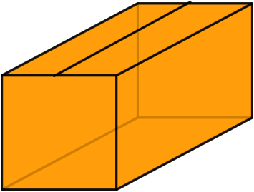

T-shaped elbow: | 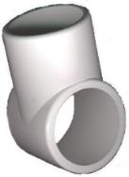 | Y-shaped elbow: | 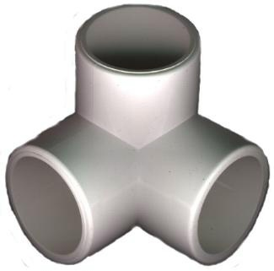

Cut the four pipes into the following lengths with hacksaw:

Pipes 1 and 2: if you are using 2’ shop light then cut 2 @ 28”, 1 @ 12”
if you are using 4’ shop light then cut 2 @ 52”, 1 @ 12”
Pipe 3: if you are using the 2’ shop light then cut 1 @ 28”, 4 @ 4 1/2”
If you are using the 4’ shop light then cut 1 @ 52”, 4 @ 4 1/2”
Pipe 4: 4 @ 27” (or longer for more height, up to 30”)

To Assemble:

Put together base with two 12” pieces for short sides, two 28” or 52” long sides, and four Y-shaped elbows. To make the top, first make a short side by putting two 4 1/2” pieces in the T-shaped elbow (in the two openings that are in a straight line), then repeat for the other side. Put two Y-shaped elbows on the ends of one of your long sides, then repeat for the other side. Connect the short sides with the long sides, using the remaining long piece down the center of the box. Connect the base to the top using the 27” pieces in the remaining opening in the Y-shaped elbows.

If you would like to paint the PVC, lightly sand all parts with the sandpaper. Spray with primer paint, and allow to dry. Spray with final color and allow to dry.

Hang the grow light from the center bar of the top, using the adjustable chains. You’ll want to keep the light about 6 - 8” from the plants, raising the light as the plants grow.

