Miami

Miami’s glitz and glamour will add a sparkle to your life!
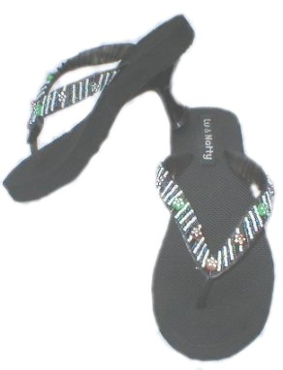
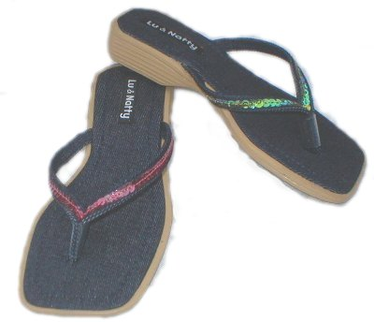
Cameron Diaz Sandal
Product Code: F3
Suggested Retail: $58.00
Available Colours: Black
Hot Pink
Turquoise
Coco Beach Sandal
Product Code: F6
Suggested Retail: $39.00
Available Colours: Green
Pink

