Roger,

I’m flying over the snowy forests and still frozen rivers of Siberia right now, enroute from Beijing back to Munich, my temporary home. It’s amazing that one can do this, technically a miracle it seems. But also this has been yet another pinch-myself kind of experience: can’t believe I got so far away from my stay-close-to home roots there in Columbus. I wish my father were still alive to hear reports of this. He’d have a hard time imagining it himself. He used to tell us, yell from the front of our 60s-something station wagon, “OK chirrens, say goodbye to Miami. You’ll probably never come back here again!” If he could only see me now, flying high over Siberia, enroute from one strange world to another strange land…all in a week’s work.

I thought the folks back home might like a report, so here it is. First a little background. We’re living in Munich right now. I’ve traded jobs with a professor from the University of Applied Sciences, who is at Cal Poly in San Luis Obispo, California right now. I know I owe you articles on my travels so far. I could and hope to write you on living in Europe, a long trip to the Mediterranean island of Malta, and on a trip to Berlin and Dresden. Time has conspired against me in doing this. On top of the normal/busy job of teaching, I’m now trying to do it in German. So it takes forever to put lectures and labs together. This trip to Beijing was so fantastic that I simply must write about it before it becomes stale.

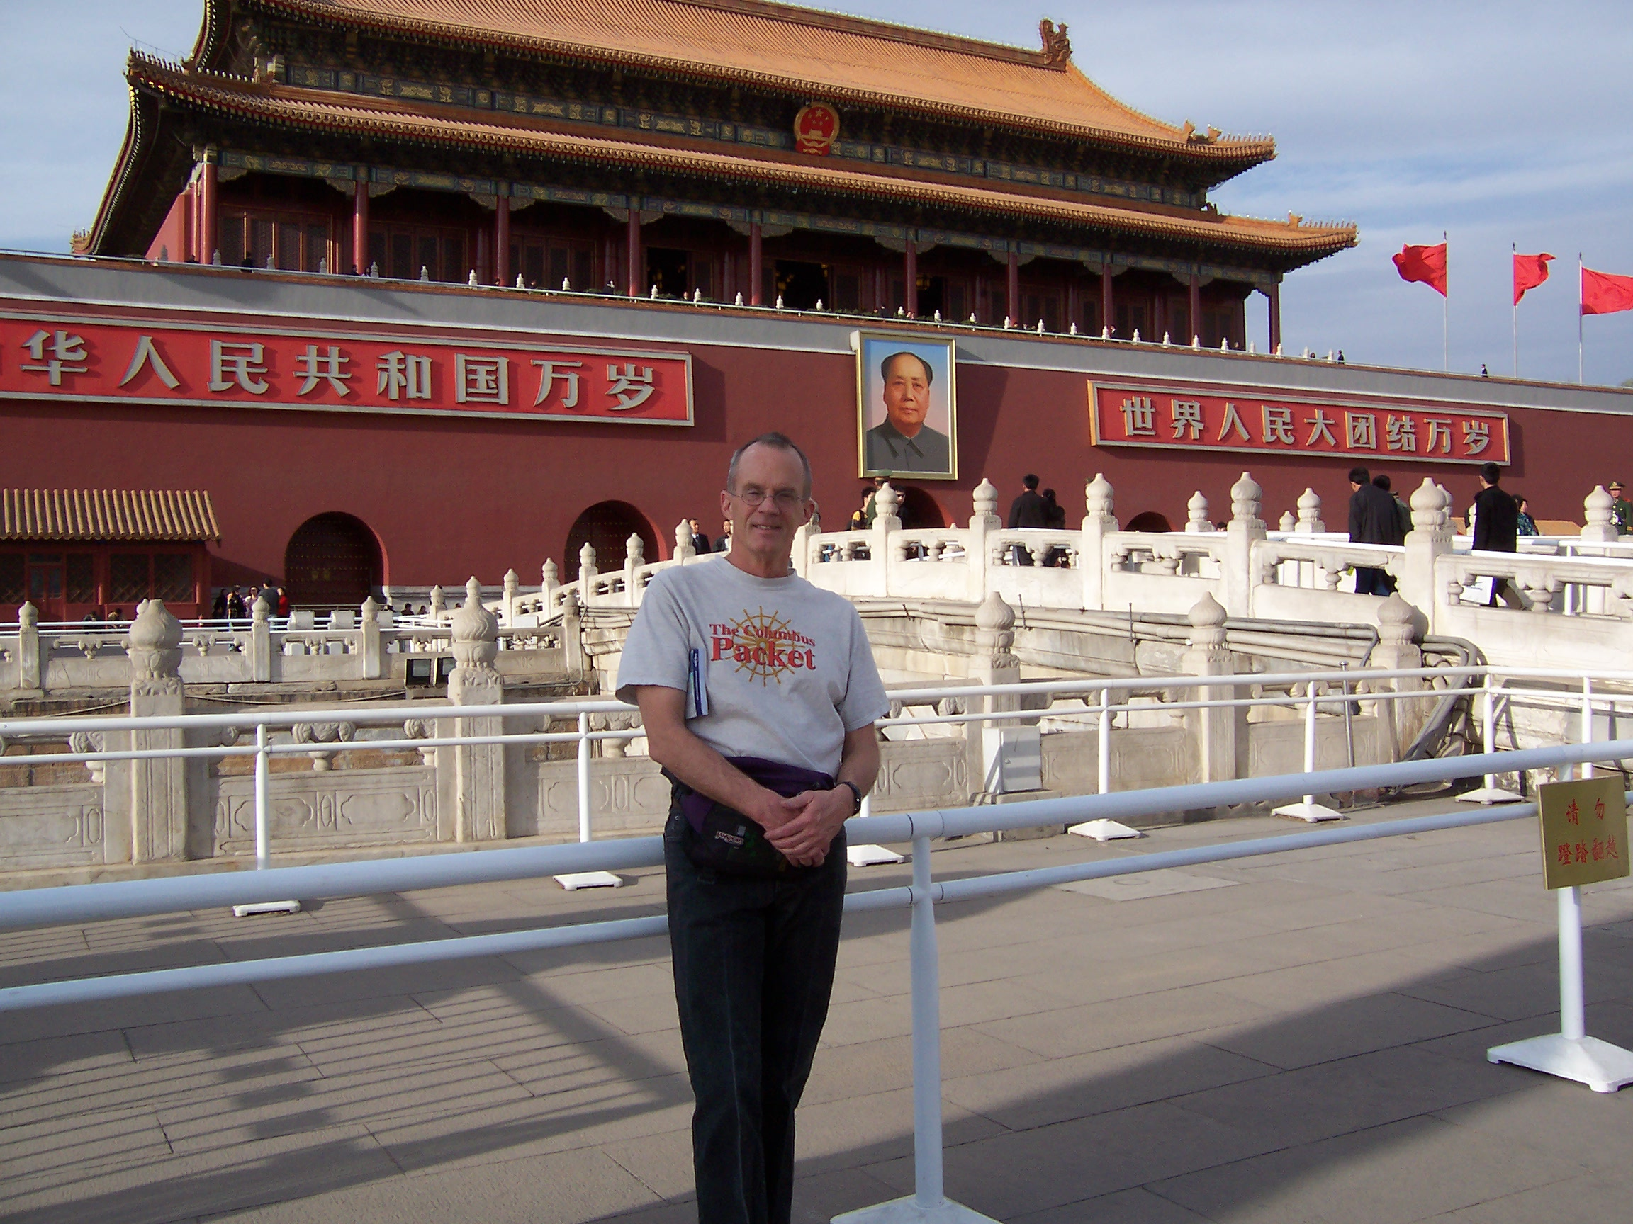
Frank Owen with his Columbus Packet T-Shirt at the Entrance to the Forbidden City

It was for an engineering education conference put on by the American Society of Mechanical Engineers. I think it’s important for everybody to know something about today’s China because there are so many Chinese, and it is such an up and coming nation. Some say that this century will be the Chinese century, much like the last one was the American century. Also the folks back home ought to be interested in China because that was one of the places to which the industries that left Columbus moved. The trip was sort of scary: scary to see this latent, seething population, scary to think about the heavy load it will place on the earth’s resources.

Springtime Beijing – Dusty, Drab, Hustle-Bustle

Beijing’s 13 hours ahead of SDT, so when it’s 8 AM in Columbus, it’s 9 PM in Beijing. I.e. today has already happened in Beijing when it’s just starting in Columbus. To get from Munich to Beijing, I flew over most of Europe and Asia, through seven time zones altogether. We passed right over Moscow and Ulan Bator, the capital of Mongolia. Didn’t get to see either because of the overcast.

You can see the air in Beijing. It is very dirty and polluted, though not as bad as the air used to be (and maybe still is) in Mexico City. It didn’t cause my eyes to burn. But it seems to be permanently hazy. It doesn’t smell that bad. But it doesn’t smell that good either. It was too bad too. I went and visited the Great Wall. It’s not far outside of Beijing, about 30 miles to the north. Not far enough. The haze was there too, so that the sweeping views of the Wall climbing up and down hills to the distant horizon were abbreviated to the immediate surroundings.

There are lots of cars in Beijing. The roads are chocker-block full of cars. They drive very aggressively. A pedestrian crossing a street has to be very careful, because cars don’t seem to treat people on foot with much respect. I think it’s that a car is a status symbol. People who walk and ride bikes are just obviously those who haven’t made it yet to car ownership. This attitude prevails in many third-world countries, especially where cars are such new consumer items.

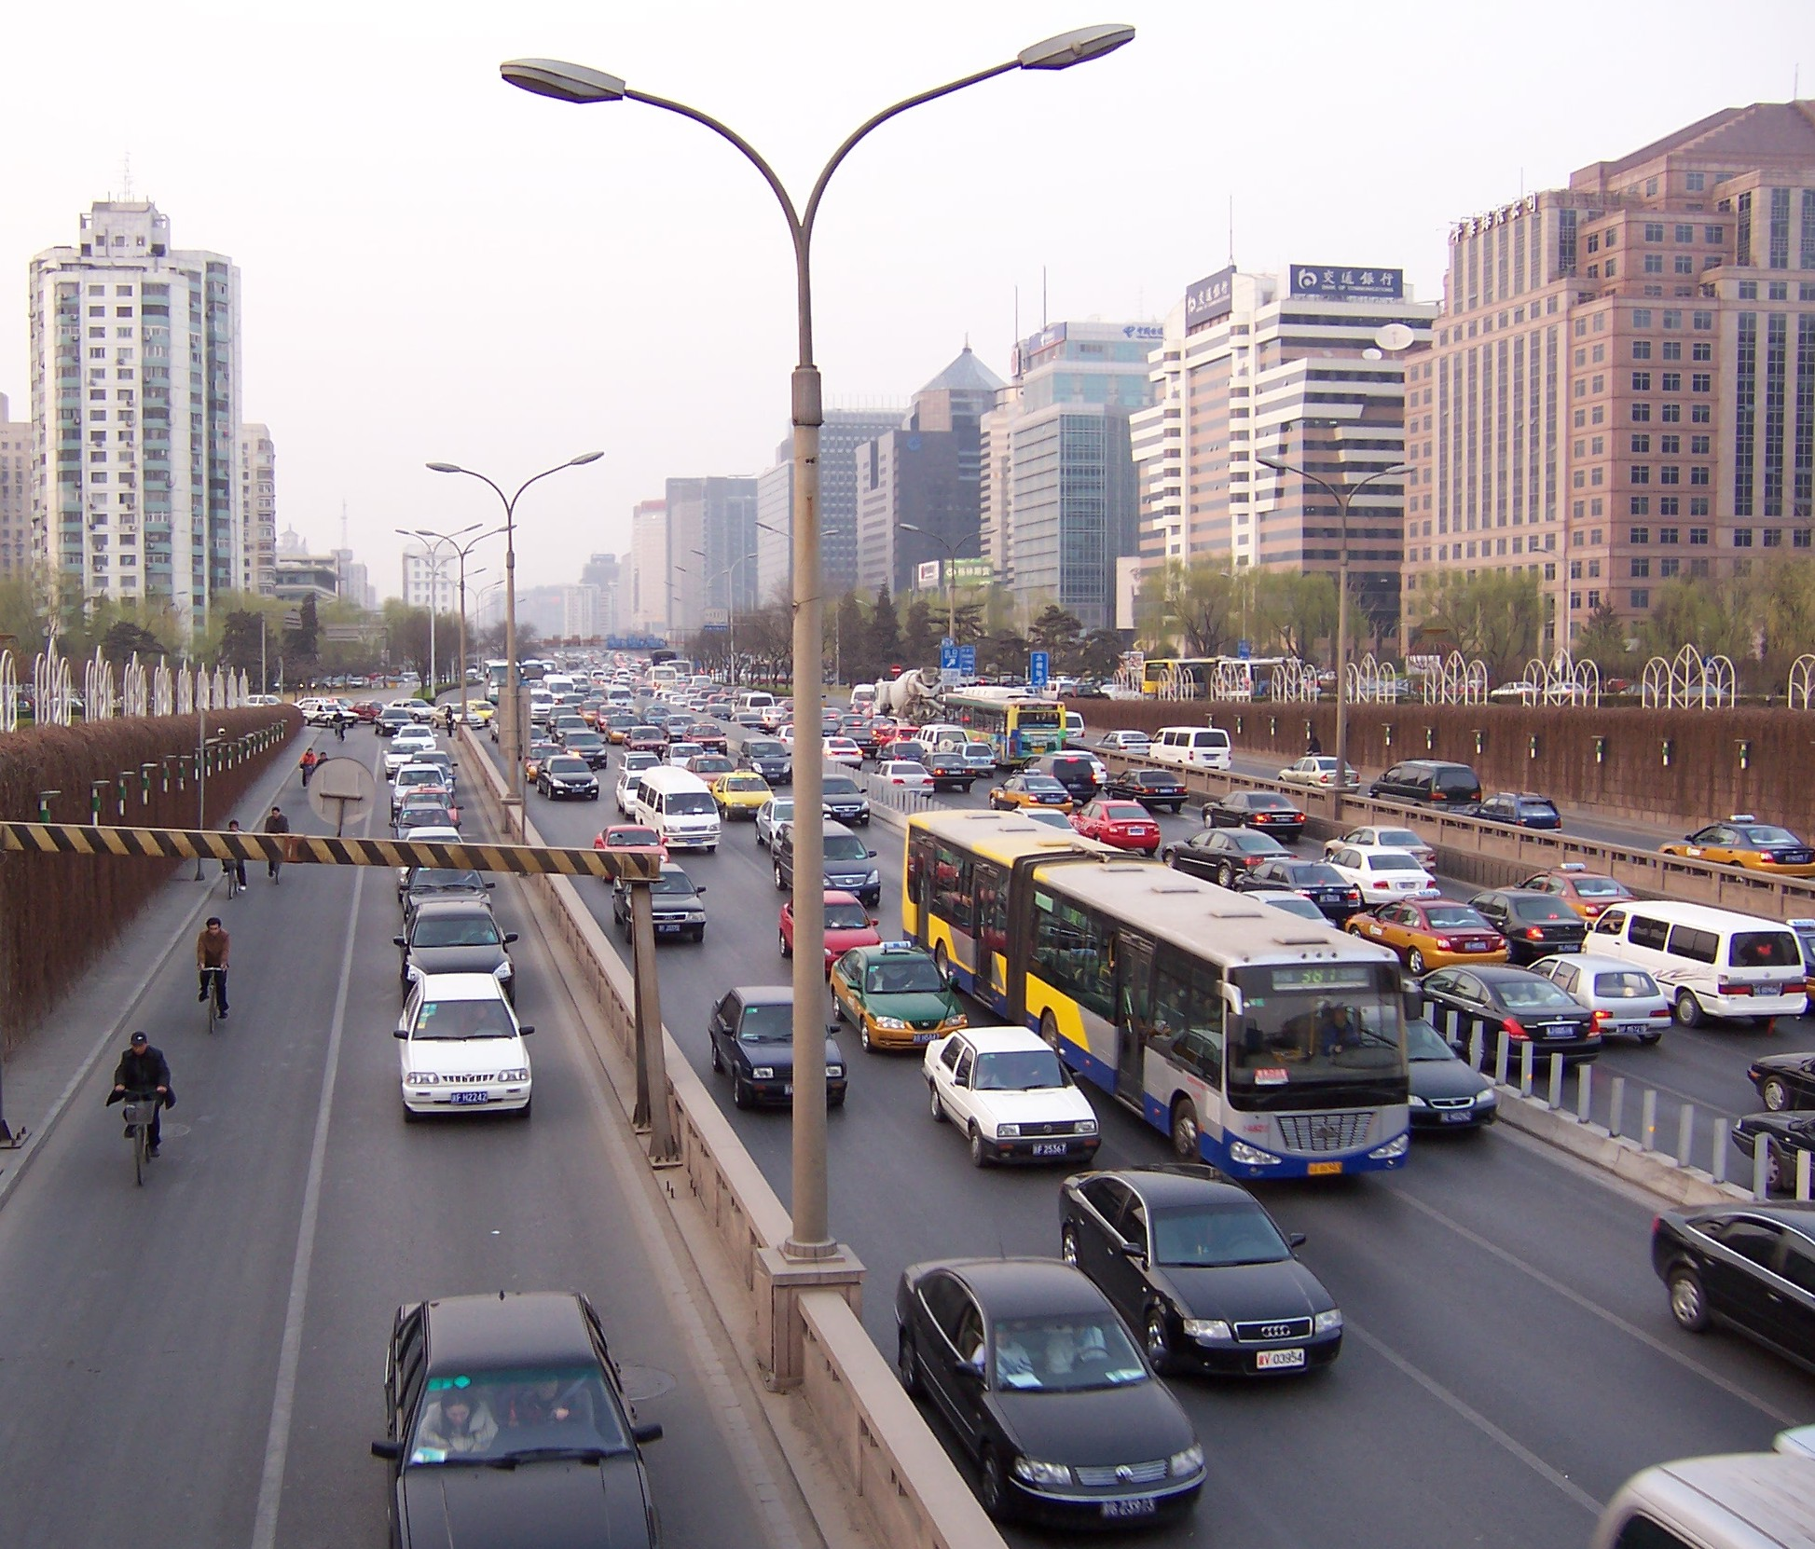
Stop ‘n go in Beijing. A lot of new cars on the streets. Actually, I found that often on a bike I was passing a lot of cars.

Beijing (and the other cities in China) will get dirtier and dirtier as more and more people get off their feet and off their bicycles into cars. I saw many traffic jams there. So not only are there a lot of cars, there are a lot of cars that don’t go anywhere very fast. Like Austin, Texas, which also has grown very fast, the day they open a new freeway, it is obsolete. They can’t build roads as fast as people buy cars to use them.

Even though China doesn’t have much in the way of oil or natural gas resources itself, gasoline is not all that expensive. It was about $2.00/gallon, less, I think, than it is in the U.S. right now. The Chinese are making deals with some pretty bad people right now, long-term petroleum supply contacts to ensure their access to fuel for the future. For example China just negotiated a deal with Iran to supply them with oil for 20 years. In return China is supplying Iran with rocket technology. Sort of scary when you remember that Iran’s president has said that Israel should be wiped off the map, and he’s insisted on continuing Iran’s nuclear development despite protests from the worldwide community. Many say that the Chinese have no scruples as a member of the worldwide community. They will deal anybody and trade anything to ensure their access to oil.

Beijing is booming. There are construction cranes everywhere. It reminded me of Berlin, which is also developing at a feverish pace. Everywhere there are new high rises. They are mostly not all that attractive either. And the dust coating doesn’t improve their appearance. Prior to this development the city was really a city of hutongs. These are little, one-story neighborhoods, mostly out of brick, with narrow winding alleyways running through them. These are still all over. I rode my bike through a bunch of them after getting over my initial reluctance to going into these private-seeming neighborhoods. The houses are built of brick right next to each other. They have internal courtyards surrounded by separate living quarters for various parts of an extended family.

But these very traditional Chinese houses are being bulldozed at a rapid rate. What takes their place are high-rise apartment buildings and business centers. And it is being done in a way that is foreign to our Western sense of private property and individual legal rights. Since technically the Communist government owns all the land, they can simply move people off who are in the way of development. Now they have private urban land ownership. So the new developers get to buy this land from the state. Actually, with the recent abuse-of-eminent-domain cases that have surfaced in the U.S., the results are quite similar. Still in China there is no private ownership of rural land. And many complain that this is a hard burden to bear for the Chinese farmer.

Beijing by Bicycle

I remember the pictures from Maoist China and the China of the 70s and 80s. Throngs of two-wheeled mobility. I couldn’t understand how all those people could ride all those bikes in such close proximity without having major accidents when, for instance, one person in the middle swerved or two perpendicular swarms crossed paths. Those pictures always stuck in my mind, so I decided that I couldn’t leave Beijing without becoming part of the teeming masses on two wheels. I rented a one-speed bike for about $6/day. It was a new bike. A one-speed is fine for Beijing because it is as flat as a pancake.

The swarms are not as big now as they were on account of people moving over into cars and onto an expanded bus/subway system. Where before the entire street was a sea of bicycles, now there are maybe three lanes of cars and two separate lanes for bikes. Our hotel was way out on the edge of town, so it took about 45 minutes to ride down to the center.

Riding there was great! The Chinese, of course, are very used to bicycles. There really is no system to it. Weaving and dodging are part of the experience. Intersections were interesting. Though cars obey the traffic signals, bikes don’t seem to. Anything goes: riding against traffic, running red lights, dodging and weaving, etc. It was fun. It was like being a ball in a pinball machine. Near the middle of Beijing, running north/south is a series of lakes. The lakes are lined by tourist-type businesses and a park-like atmosphere. The streets there weren’t crowded like the regular urban arteries were. So I’d use that to get from the top of Beijing to its middle. Very scenic and convenient.

The Food – Whatever You Want

There was a market that all of us conference attendees visited. All the cheap stuff you folks find at Wal-Mart, well, it was all on sale here. That and more. But you really have to haggle. Prices start at about four times what you can buy the item for. You should start at about 1/10th the price and work your way up. Many tourists just pay the asking price, which is very low, or only haggle down to a half.

The Chinese are very poor on average, making only a little over $1000/year. But things are very cheap. I told one of my conference-mates that we must be like the lottery for them, yet probably the odds of fleecing one of us is much better than hitting the lottery. Once you start into bargaining, it’s hard to stop too. If you try to walk away, they actually grab you or tug at your clothes to keep you there. Most of my bargaining sessions ended with me dragging a clutching merchant away from her stall (most were women) until a little way down the alley she’d either let go or concede to my last offer. I felt bad sometimes about driving the price down so low. But there are many other tourists to fleece, so I didn’t feel that bad.

One street was the “Snack Street” where you could buy almost any kind of food you wanted. Most was on a stick. A stick of grilled bugs. A stick of about five frogs. A stick of grilled scorpions topped by a fried seahorse, yum. Fried starfish. A friend ate a grilled centipede and said it wasn’t too good.

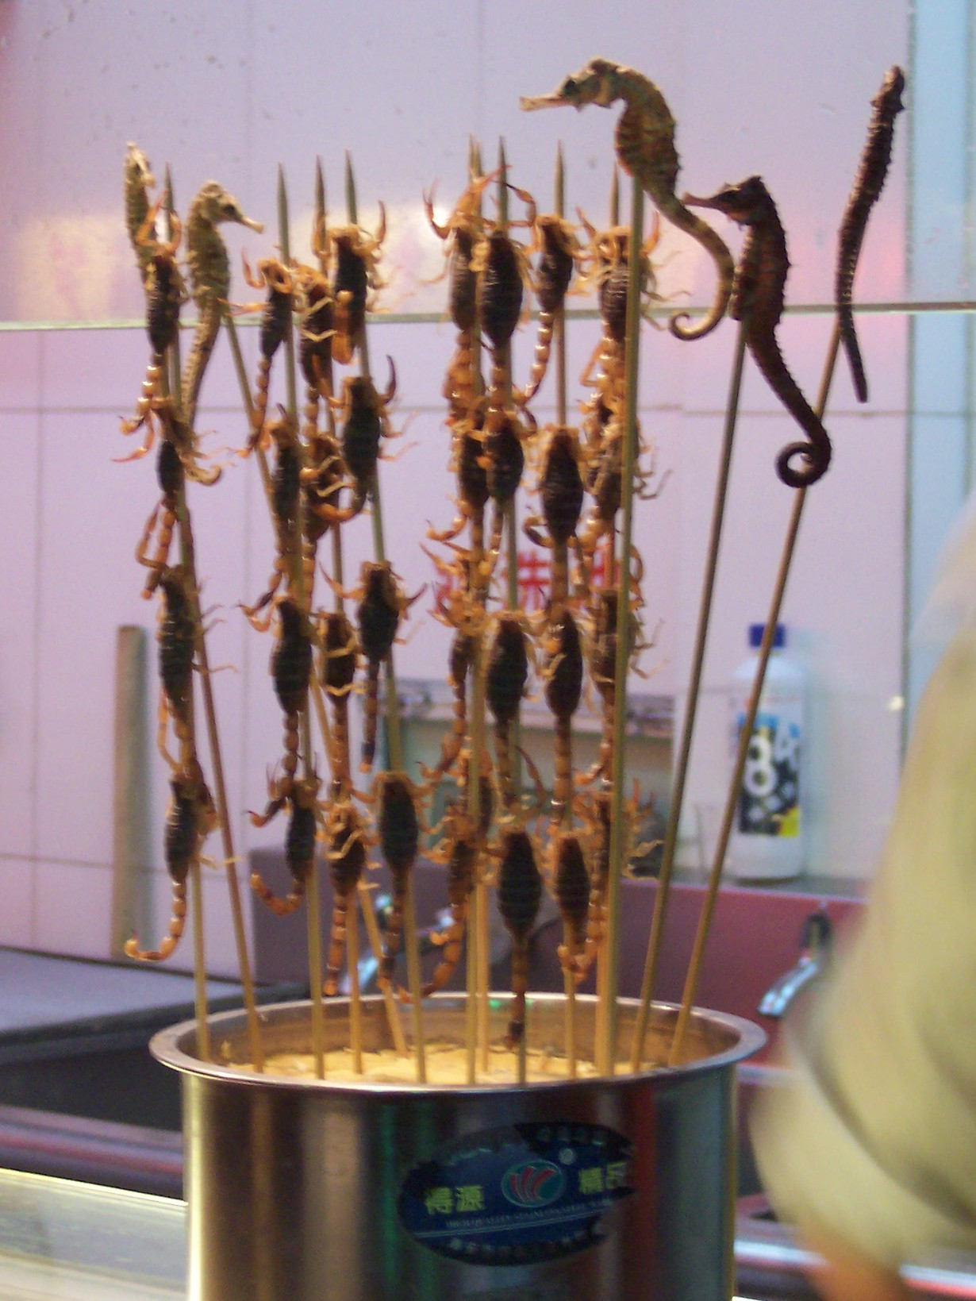
Fried scorpions and seahorses on a stick

Of course it was hard to order stuff at a restaurant. It’s bad enough in a foreign language when the characters are from the regular Roman alphabet. But with Chinese characters, there’s no way to even sound anything out. Luckily they had pictures, at least of some of the stuff. We went our last night in Beijing to a little local place with a colleague from Cal Poly- Pomona, who originally came from Taiwan. So she could read and speak. Some of the things offered were too exotic for us, like the private parts of goats and sheep. Luckily they didn’t have any pictures of these entrees.

At the tourist market there’s a lot of Mao memorabilia. To some Chinese, he’s still a hero. Many tourists come and have a curiosity about the Mao times. So you can buy Mao hats, little red books, and Mao watches. On the face of a Mao watch they’ve set it up so his hand waves as the second hand moves. So the Mao on a Mao watch is waving all the time. He’s very friendly there. Too bad he wasn’t so friendly in real life. He was responsible for the death of millions of his fellow countrymen. Still his face is everywhere. There’s a big portrait of him up above the entrance to the Forbidden City in the middle of Beijing. And you can even file past his body in the state mausoleum. The current Communist Chinese government even now admits partially to his mistakes. In their infinite and unfathomable wisdom, they’ve decided he was right 70% of the time and wrong 30% of the time. The Mao watch only costs about $2. Hey, he’s not waving all the time. In fact he’s only waving about 70% of the time. Sometimes I have to give the watch a couple of raps to get Mao to start waving again. Could there be a connection?

Coming out of Communism

What China has now is officially known as “state-sponsored Capitalism”. So we have a Communist government that supposedly sanctions, directs, limits, controls capitalism. Didn’t Marx say that the two systems were fundamentally at odds? What seems to have happened is that the government has ceded control to market forces as needed to prevent an uprising against them. But Pandora’s box is opened. The raw power and forces of free enterprise are evident everywhere. And I had to ride a long way on a bicycle before I even saw a policeman. So today’s China is a long way from the police state of Maoist times.

Mao’s picture is in a lot of government places. His beaming face is not just on the money, it’s on all the money, on every bill from 1 Yuan on up. But you don’t see his face on private buildings. You do find Mao figurines right next to brass Chinese dragons and statuettes of fierce warlords. So he sells. But I think he sells mostly to tourists. To us he’s a little bit like Elvis. Seeing his portrait on money and lots of government buildings is like seeing Elvis’s there.

There have been lots of critical books about Mao and the Cultural Revolution out in the past few years. As each book is published, his reputation takes another hit. These books are all available inside the country and also in Chinese. So the government hasn’t even been able to keep this information away from the people. One problem with that is the Internet. There are Internet cafes everywhere, and apparently what one can receive is not highly monitored. For us, Communism went hand-in-glove with secrecy and oppression. The lack of either in today’s China shows how much the government’s hold has slipped.

But one thing worries me. There was no George Washington in China’s past. There were no Founding Fathers or a Constitution like we have with personal rights built into the fiber of the nation. So even though today’s China appears open and free trade- oriented, where are the guarantees? And where are their principles and scruples? They seem willing to make deals with anyone for their energy future and economic advantage.

Chinese Engineering

I was in town for an engineering conference. Engineering is big news in China. They give a lot of credit to their cleverness in this field for the great strides they’ve made in the recent past. Many speakers said as much. We had several top officials from the Chinese government visit us and give talks at this conference. And we even got invited to the Great Hall of the People for supper one night. That’s like being invited to the U.S. Capitol for supper. My engineering career started at Mississippi State. Look how far it can take you.

But there is a worry on the horizon, some worrisome numbers that have shown up. Engineering is not the glamour profession that it was in the 1960s, when John Kennedy urged us to get up off our behinds and beat the Russians to the moon. So we professors spend a lot of effort trying to coax smart youngsters to go into this field. The Chinese have the opposite problem. Engineering is highly respected in China. It is a cornerstone of China’s catching up with the industrialized world. The engineering schools are jammed full, and they’re turning people away. A Chinese engineering student is under a lot of pressure. If he or she does not perform, there are dozens of others waiting in the background for the empty space that his or her failure will leave.

The popular New York Times columnist and current affairs author, Thomas Friedman, said in his recent book, The World is Flat, that there is a twist to the old saying we used to hear from our parents: “Eat all the food on your plate. There are starving children in Africa.” Today’s version of that applies to intellectual activity and applies to China and India, both of which are zooming into the First World: “Do your homework. If you are can’t make it in the working world, there are dozens of Indian or Chinese workers who would love to have your job.

What’s to Come?

In one way in particular China is a very scary place. It’s the numbers of people. They have as many students in China as we have people in the United States. The country is urbanizing at a rapid rate, though there are still a majority of people in the countryside. But the air in Beijing and other Chinese big cities is very dirty. China is burning up 1/3rd of the coal that is used on earth. There have been several very dirty, damaging chemical spills and industrial accidents recently in China. With so many people, live is regarded rather cheaply, by our Western standards. The projections of explosive economic industrial growth that will happen in the next decade, the huge numbers of people, the already sadly polluted state of the urban landscape in China…that all adds up to a lot of worry in my mind.

Thank You, Homefolks

I never stop being amazed that I’ve come so far from my home roots in Columbus. I wish Virginia Mae Ferrill were still alive to see this, how far someone can get from hometown roots, how foreign the environment and landscape can be, and still I can deal with it and make sense of it. I feel like I owe a great debt of gratitude to a lot of people in that sleepy little town, the ones who pointed out paths to me, showed me the way into the future. I don’t think that even they knew the extent of those paths, how far away from Columbus they could lead. But they did lead me really all over the world. So a big thanks to those folks, many of them now long gone.

