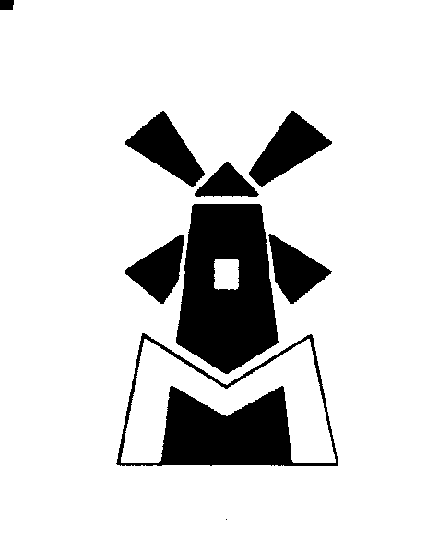FALKAR TRAD & ENGINE LTD.

FLORENZER STR. 54, 50765 COLOGNE, GERMANY
Tel: +49 (0221) 70 89 137
Fax: +49 (0221) 70 68 48
E-mail: usedmachine@debitel.net
usedmachine@yahoo.com
http://www.geocities.com/usedmachine
http://go.to/candy.com

----------------------------------------------

1. CRUDE OIL REFINERY
100,000-- BPD OIL REFINERY, LOCATED IN THE UK.
THE PLANT WAS SHUT DOWN IN JUNE 2000.
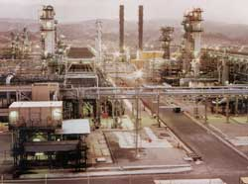
-----------------------------------------------
2. USED COMPLETE HEAVY SEAMLESS TUBE MILL PLANT
COMPLETELY REFURBISHED AND COMPUTERIZED IN 1981
6-5/8" to 14-3/8"(168 ~ 365 mm) Capacity
Oilfield or Construction Tube
Complete Production Facility from Start to Finished Product
Including Heat Treating.

------------------------------------------------

3. CEMENT PLANT
This cement plant has never being used and is sitting on a dock in
Crates ready to be shipped on a FOB basis.
The plant can produce 1.2 Million tones of cement per year.
This plant HAS NEVER BEING USED, was manufactured in 1994 - 95.

------------------------------------------------

4. NEW TYRE RECYCLING (CRUMBING) PLANT
We can offer a complete tyre recycling plant at a greatly reduced price. The equipment is made in to high standards and built to last.
This plant carries a 1-year warranty against manufactures parts, excluding blade ware)
The plant can produce about 1 ~ 2 tones/hour of rubber crumb.
This is a good opportunity start a new business in an expanding market, or to upgrade your existing equipment.
, further information available.

-------------------------------------------------
6. AIRCRAFT/TRUCK TYRE REMOULDING PLANT
It has been dismantled from the Michelin factory in Switzerland. This plant would produce about 80 various aircraft / truck tyre per day.
It is now in Holland.

-------------------------------------------------

7.COMPLETE WELDED-STEEL PIPES PRODUCTION PLANT
"CONDITION AS NEW"
YEAR OF MANUFERED.1995-1997

PLANT WAS IN "TEST RUN" OPERATION=85=85=85=85=85=85ONLY FOR ABOUT 3 MONTHS.
PARTIALLY INDIVIDUAL LINES, ARE STILL AVAILABLE IN SEAWORTHY CRATES
NEVER USED.
ALL MACHINERY WESTERN EUROPE/ MANUFACTURED

-------------------------------------------------

8.CRUDE OIL REFINERY
Refinery for sale with a processing capacity of 30,000 BPD
The plant is 1 year old and dismantled ready for shipping.

Installation & commissioning available, subject to separate contract etc.

-------------------------------------------------
9.CRUDE OIL REFINERY
PROCESSING CAPACITY OF 110,000 BPD
Located in Europe.
The refinery has been shut down for 7 years, but has been kept in very good condition.

--------------------------------------------------
10. CRUDE OIL REFINERY
Refinery with a 8,500 BPD capacity. The refinery, which has the metallurgy, required to process a sour crude was completed and started operating in late 1989 and was shut down in August of 1993.
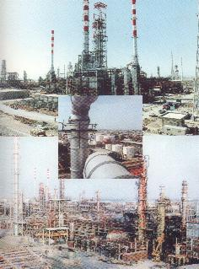
--------------------------------------------------
11. CRUDE OIL REFINERY
Refinery with a capacity 100,000 BPD located in USA, currently in operation. Pipeline to major USA port. Sold as existing operation etc.
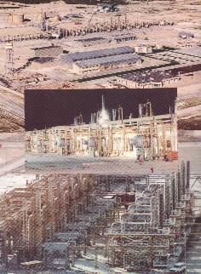
--------------------------------------------------
12.COMPLETE BOTTLING PLANT
The plant is capable of producing 6,000 1-ltr plastic bottles per hour.
It is capable of filling 24,000 bottles per hour.
The plant origin is Swiss.
Make: Dian Blow.
The plant is in very good condition, and can be seen running at the moment.

--------------------------------------------------

13. CD (COMPACT DISCS) PRODUCTION PLANT:
As used in computers, music industry, games industry etc.
Plant is in "as new" condition (originally manufactured in
1999-2000) Well known brand of equipment
Production capacity: 2.5Million CDs per month
-------------------------------------------------

