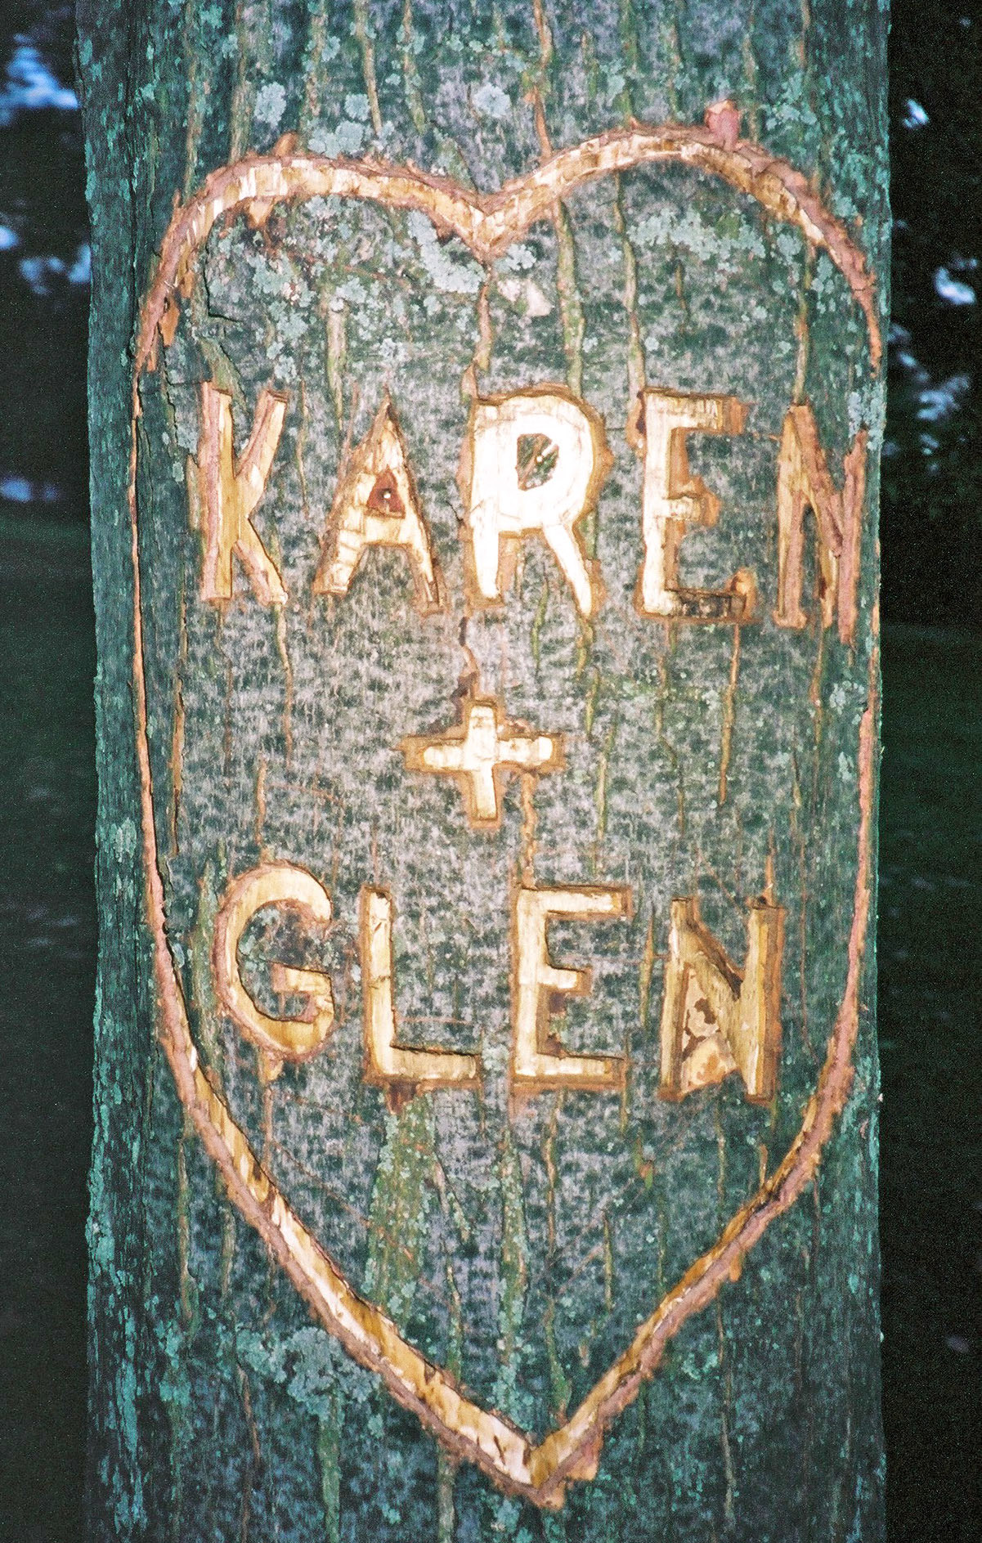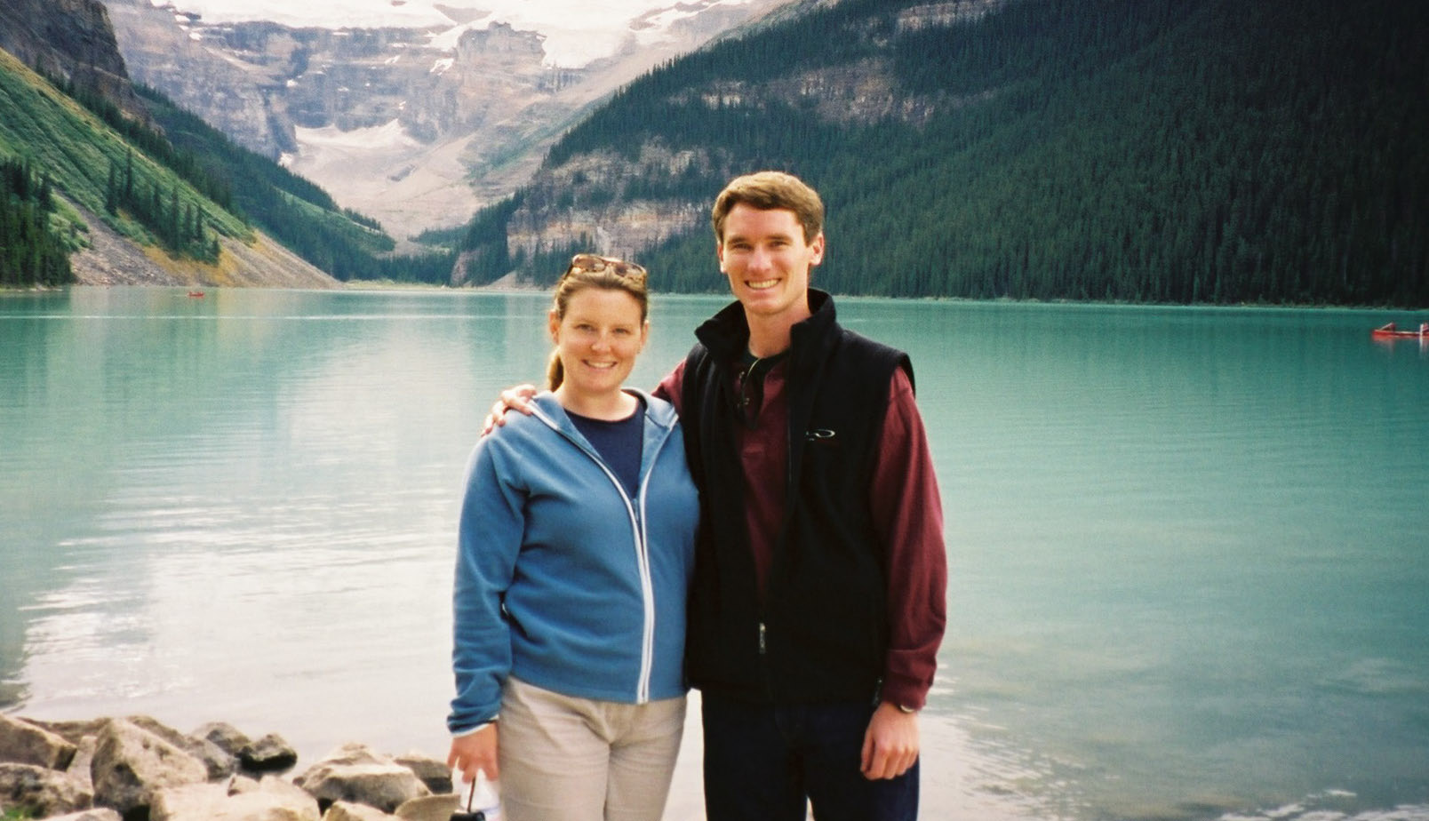

Save the Date!

Glen Webster and Karen MacLellan
Plan to Wed !
Saturday, July 31, 2004
Judique, Nova Scotia

Dear Family and Friends:

We are getting married on July 31, 2004 and
would like you to join in our celebration.
As summer is a busy time, we wanted to
let you know ahead of time about our intended plans.
Cape Breton Island is a wonderful place to explore and experience
so plan to spend a few days if you can. Below is
some helpful information about travel and accommodation.

Formal invitation to follow late Spring 2004.

We hope you will join us!

Karen and Glen

A Wedding and More

Our goal is to have a wedding weekend full of fun events so that we have a chance to visit with everyone and our guests have time to visit and enjoy Cape Breton.

For those who are able to come up early, we are planning to have a golf tournament at one of the many superb local courses on the Friday morning before the wedding. A “Rehearsal Dinner / Lobster Boil” will also be held on Friday evening in Judique for guests coming from outside of Nova Scotia. And we’ll be around for a casual brunch at the Maritime Inn in Port Hawkesbury on the Sunday morning.

For all your travel plans we suggest contacting Nova Scotia Tourism by calling 1-800-565-0000 to request their Doers’ and Dreamers’ Guide and visit their website at www.novascotia.com or e-mail them at info@checkinnovascotia.com.

Ceremony and Reception

The Ceremony and Reception will be held in Judique, Karen’s home town (see maps below).

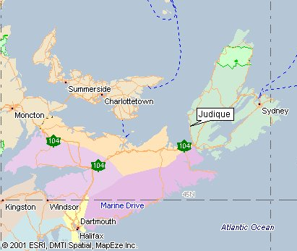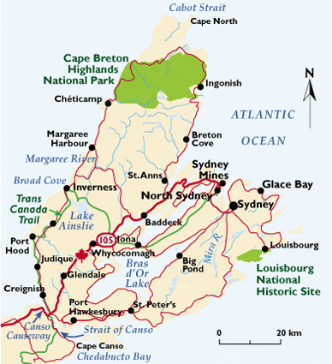

Getting to Cape Breton

For those of you from outside Nova Scotia, we recommend flying in to Halifax International Airport since Judique is not much closer to the Sydney airport and most flights go through Halifax on their way to Sydney anyway. The drive from Toronto is approximately 1850km and takes over 20 hours of straight driving.

Cape Breton is about 3 hours driving time from Halifax International airport.
- Go North on PROVINCIAL HIGHWAY 102 to TRANS CANADA 104 for 73km
- Go East on TRANS CANADA 104 to PROVINCIAL HIGHWAY 19 for 160km
- Go North on PROVINCIAL HIGHWAY 19 for 28km into Judique.

For your own driving directions please visit http://www.mapquest.com/directions/

Car rentals are available at the Halifax airport. Please book in advance as this is a very busy time for tourism.

Accommodation

Cape Breton is a great base for lots of fun activities including golfing, hiking and just plain relaxing. Cape Breton offers a wide range of accommodation, but late July / early August is the busiest time of their tourist season. Please book your accommodations as soon as possible (preferably before January 15, 2004) to avoid disappointment from the lack of vacancies.

Block of Rooms:

A block of 30 rooms is being held under the “MacLellan / Webster Wedding” at the Maritime Inn in Port Hawkesbury, a 25 minute drive from Judique. Please contact the Inn directly at 1-888-662-7484 to make your own reservation as soon as possible.

We also anticipate dropping in at the Maritime Inn for brunch on Sunday morning after the wedding, so we expect that this will be a good gathering spot for out-of-town guests.

Martime Inn - Port Hawkesbury
http://www.maritimeinns.com/porthawkesbury/index.html
73 suites
Indoor / Outdoor pools
Outdoor play area for children
Fitness centre
No elevator
3.5 stars
$109 -135 / night
1-888-662-7484

Some of you may prefer other types of accommodation for your trip. We have listed some of the other options in the local area for your perusal. Please feel free to discuss your options and make reservations directly with Nova Scotia Tourism at 1-800-565-0000.

Cottages
Chisolms Coastal Cottages – Troy | Lighthouse Cottages – Port Hood
http://www.chisholmscottages.com/ | http://lighthouse-cottages.com/
4 stars | 9 two bedroom cottages
6 two bedroom cottages | $109 or $665 / week
5 one bedroom cottages | boardwalk to the beach
ceiling fan, no air conditioning | Rachel & Colin MacDonald
$119-$149 or $700-850 / week | 1-902-787-2787
1-877-626-3285
Hillcrest Hall Country Inn – Port Hood | Haus Treuburg Country Inn & Cottages – Port Hood
http://www.hillcresthall.com/ | http://users.auracom.com/treuburg/
3.5 stars | 4 stars
11 bedrooms, each with bath | 2 rooms
walk to the beaches | 1 suite in the house
$81-130 | 3 two-room cottages
(888) 434-4255 | $90-130
 | 902-787-2116

Motels
Howard Johnson Inn Highland Gateway  – Port Hastings | MacPuffin Econolodge Motel  – Port Hastings
http://www.the.hojo.com/porthastings13684 | http://www.micmachotel.com/macpuffin/index.html
69 rooms with air conditioning | 3.5 stars
15 with fridges and microwaves | dining room
$81-108 | heated pool
3 stars | 43 air conditioned units
1-866-550-4656 | $79-139
 | 1-800 867 2212
SkyeLodge – Port Hastings | Port Hawkesbury Motel
http://www.skyelodge.com/ | 2 and a half stars
dining room | $56-88
49 air conditioned motel units | 28 units
$70-89 | 902-625-2480
1-888-832-7593
Bed & Breakfasts
Rachel’s by the Sea Bed & Breakfast - Judique | Inn on the Interval – Judique
http://scarano.homeip.net/bythesea/ | 4 rooms with bath
4 bedrooms, shared bath | $90
$55-65
no pets
902-787-2741
Harbourview B&B – Port Hawkesbury | La Marguerite B&B – Port Hawkesbury
http://www3.ns.sympatico.ca/harbourview.bb/ | http://www3.ns.sympatico.ca/7.macneils/
no pets | 3 bedrooms, shared bath
1 bedroom with bath | no pets
2 bedrooms with shared bath | $48-80
6 Motel units with bath | (902)625-0476
$45-75
1-877-676-6886

Other websites of interest

For those thinking about doing some other traveling or touring, here are some potentially helpful sources of information:

Handy tourism websites:
http://www.novascotia.com/ 1-800-565-0000
http://explore.gov.ns.ca/aboutns/capebretonisland.htm
http://www.cbisland.com
http://www.pc.gc.ca/pn-np/ns/cbreton/index_E.asp
http://nsonline.com/Cape-Breton/Travel/Accommodations/Hotels_and_Motels/

All things Judique:
http://collections.ic.gc.ca/celtic/judique.htm

Golf courses:
http://www.capebretonresorts.com/dundee.asp - likely for the golf tournament
http://www.golfcapebreton.com/
http://highlandslinksgolf.com/
http://www.bellbaygolfclub.com/
http://leportagegolfclub.com/index_eng.html

Potential entertainment on the Sunday evening:
http://granvillegreen.com/about.html

Ceilidhs at The Creamery
http://www.ceilidh.ca

Contacts

We look forward to speaking with you soon! For more information, please call or write us:

Glen & Karen 416-593-6121
glenwebster@yahoo.com
maclellan_karen@hotmail.com

John & Danena MacLellan 902-787-3452

Brian & Gay Webster 519-448-9458
forestcityyearling@rogers.com

