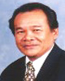

Principal

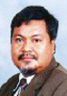
HEP


Advisor
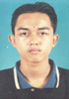





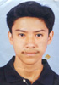

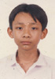

President
Ass. Pres. I Ass. Pres. II Vice Pres. Treasurer Secretary
Sports Food & C.I.S Welfare Cultural Management Islamic Academic
Nutrition of Activities

