


Hi everyone!

I thought I’d send this out to let you all know what I’m up to at the moment. I graduated from the University of York last June, obtaining a First Class degree in Electronic Engineering with Music Technology Systems. I’m spending this academic year in a gap year project with the charity Youth For Christ (YFC). YFC run a band called TVB (Truth Versus Belief), and I’m their sound engineer this year. TVB work with young people, mainly in schools, sharing the Christian faith. We’re not based anywhere, instead, we find ourselves in a different place each week. Life on the road has good and bad points; constantly living out of a bag is a bit of a pain but I’m seeing a lot of new places and getting to know the M6 really well!

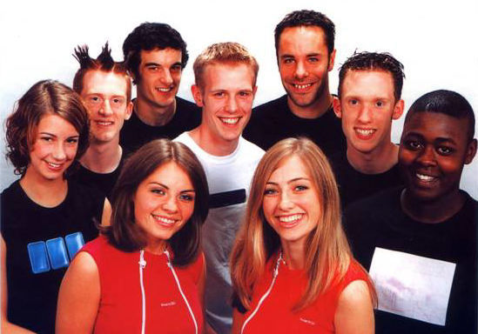
TVB consist of nine members:
(L to R)

Ruth – keyboard
Simeon – bass
Myself – engineer
Pete – vocals, rhythm guitar
Martin – leader, lead electric guitar
Steve – DJ
Dumo – drums
Theresa – vocals
Joey – vocals

Everyday life

As well as doing the sound with the band when we play gigs, assemblies and mini-concerts in schools, I drive the minibus and I am actively involved in taking school lessons. We do two types of lesson, the ‘band lesson’, where we take several classes in the school hall, and normal classroom lessons. The band lesson has lots of games, sketches and songs to convey the Gospel to the young people in a really exciting way. I give my testimony as part of the lesson, which is always a little daunting. We often do the band lesson with up to 300 pupils, and I can tell you it’s a bit scary to have that many faces looking at you! We’ve had a laugh because at my interview with TVB I said that I consider myself to be a ‘sitting at the back’ person, and that it would take a lot of God’s strength to get me on stage!!

In the classroom TVB take a variety of subjects; for RE we have several lessons such as ‘What is a Christian’, ‘The Ten Commandments’, ‘Self-Worth’ and ‘Christianity and Lifestyle’. We sometimes take lessons like these as part of the PHSE curriculum. Occasionally we do music lessons or even drama! It has been quite strange to stand in front of a class of teenagers and take a lesson, even though the teacher is there I often feel like I’m not qualified! I’m getting used to it though and it’s really amazing to be able to answer young peoples’ questions about Christianity and what we believe about specific issues. They are all really eager to find out about God and it’s really something to be able to dispel all the stereotypes and misconceptions they have about what it means to be a Christian.

Rock, roll and the Gospel

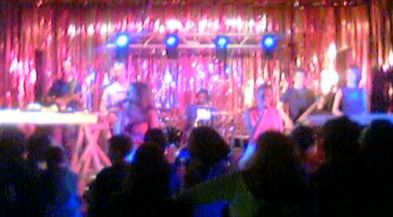
The highlight of our week is the end-of-week gig. We use every assembly, lesson and lunchtime concert in the week to hand out flyers for the gig and also try to build relationships with young people to personally encourage them to come. The gig is really professional, an exciting and engaging experience. If we are ever near you come and see us!! The point of the gig is the talk at the end. This is usually given by the band leader, Martin. The Gospel is presented plainly and simply, building on the events of the week. The gig environment is a lot less restrictive than in school in terms of what we can say. The young people are given a chance to respond to the Gospel, to agree with a prayer of commitment by raising their hand. I am always amazed at the response we see, God really does move through us. We always see teenagers who want to know Jesus. We talk to everyone who raised their hand at the end, pray with them and take their details so the church can follow them up. The best thing about being on TVB is to have got to know someone in the week at school and then to see them respond at the gig and to talk to them about God, pray with them and introduce them to Jesus.

Future plans

I’m off for Christmas at the moment, a well-deserved three-week break. We often have to leave our accommodation at 6.30am to set up for an assembly, then if we have an evening gig we don’t get back until after midnight! Sleep is a rare commodity usually reserved for our day off each week! Next term starts with YFC Staff Conference, a week of teaching seminars and celebrations. I’m on PA for the week so it won’t be too relaxed for me! It’ll be good to see the other YFC gap-year volunteers there, who I haven’t seen since our initial training last September. After Staff Conference TVB are straight back on the road, but I don’t actually know where the first week is yet! I’ve got used to not knowing things in advance with TVB, the culture is more of being able to do anything required with 30 seconds notice (not an exaggeration- eg. Martin: “Right, we’ve got a ‘What is a Christian’ lesson now, Matt and Ruth and me are taking it, let’s go!”)!!

Things to thank God for

- Young people becoming Christians
- All the unseen seeds sown
- Kicking off new opportunities for local Christian witness in schools
- That the team has bonded really well

Prayer requests

Life on the road is really hectic and it is easy to become tired and discouraged. Personally, I really need prayer for energy and enthusiasm, and prayer against discouragement. Tiredness can be responsible for so many destructive little things, such as petty arguments within the team. Other things to pray for:
- Protection over the equipment
We have a great new PA system, but it has had many teething troubles, with several units needing to be replaced. Also we’ve had several problems with the van, which we could really do without as we can’t function without it!
- Team health
Fortunately we’ve had no major problems, but we need each member of the team to fully function, illness in any part really affects the whole. It’d be great to have people praying against illness.
- Personal walk with God
In all the rush of early mornings, late nights and busy days it can be easy to neglect spending personal time with God. Pray that I would be able to make time for that.
- My financial situation
See below

Financial issues

I don’t know if you are aware of my current financial situation. A gap year with YFC costs the volunteer £2900. Added to that are everyday out-of-pocket expenses. I am currently surviving off my graduate overdraft, although I have some savings to help balance things at the end of the year. I used some leftover student loan to pay almost half of the amount required by YFC. I hope to get a reasonably well-paid job next year, but am still daunted by my £11,000 student loan which costs £20 per month in interest.

Being ‘in-between churches’ since leaving York (having left my York church, and not been around in Lincoln much at all), I find it difficult to find people to support me. I have received a total of £100 towards the year which I am really thankful for, £50 from York Uni CU and £50 from a church TVB worked with in Wakefield. I am well aware that most people reading this will be in a similar situation to me, either in a gap year, a student or just starting out in a job so I don’t want any of you to part with what little money you have. For those in a more comfortable financial situation, I must ask whether you would consider blessing me and Youth For Christ with any financial support. If you would like to, you could send a cheque to me at 49 Yarborough Crescent, Lincoln LN1 3NF. I won’t be there but my Mum will put it in the bank!

A bit of a plug…


After finishing training, TVB recorded this year’s album, ‘Kindle’. I was heavily involved with this, engineering and mixing the tracks with full band. The album has ten original tracks on it and only costs £6. Buying one is a great way of supporting the ministry of TVB and getting a great album too!! You can get one either through me or through the YFC website at http://www.yfc.co.uk (follow links to Creative Arts Teams then TVB)

Finally…

Please keep in touch. I’m sorry for not being better at that myself. When I’m on the road you can contact me via my phone:

Voice and SMS: 07930 337320
Email: mattneighbour@fish.co.uk

It’s always great to get email on my phone, so much longer than a text message! My phone can take, send and receive jpeg pictures, so it’d be great to really see what people are up to! (send approx 300x300 pixels, <30kB files) Oh, and for York Uni CU people past and present, if you haven’t already, sign up at http://groups.msn.com/YorkCULeavers2002 to be part of our cool keeping-in-touch messageboard site!

Take care, keep in touch and God bless you,

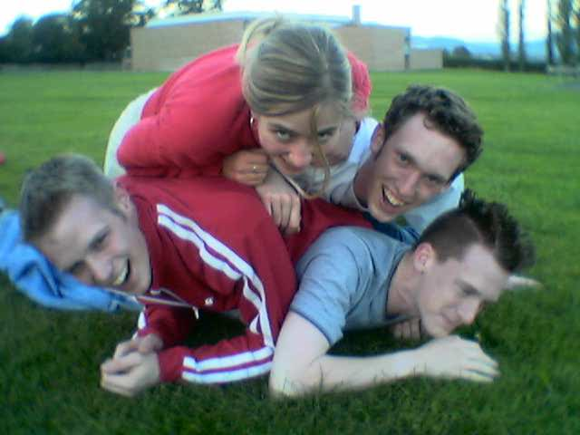

Matt

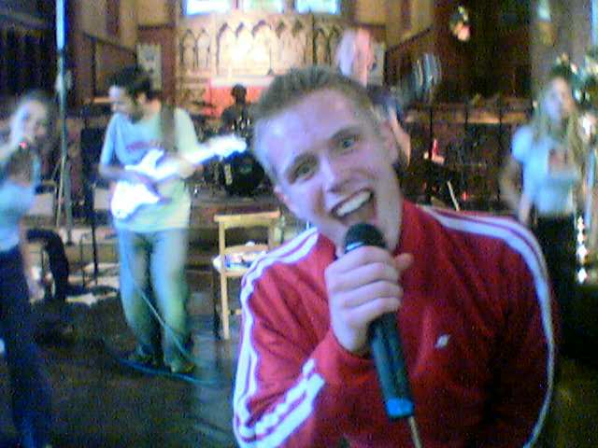

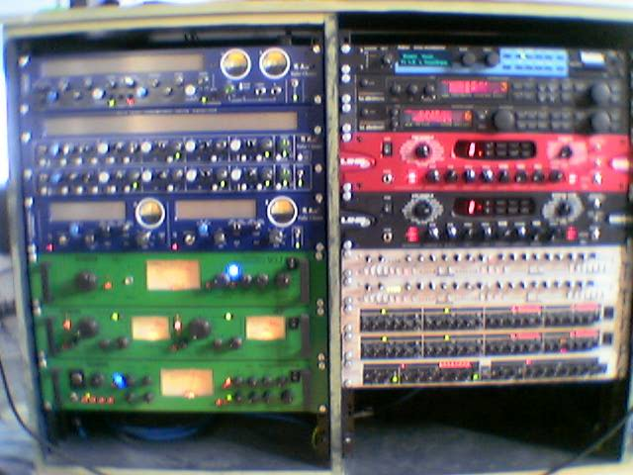



British Youth For Christ is a registered charity.

