Mike Colvin
Extra credit project
Physics III – Dr. Gabriela Popa

Electric Motors

ABSTRACT: This project describes electric motors and how they function. My motivation for doing it was to find a real-life, concrete application of a topic we’ve discussed in class. After a little research, I found that the driving force behind electric motors was the magnetic field created by a current, a topic we’ve discussed in great detail.

A basic electric motor has six main parts: an armature or rotor, a commutator, brushes, an axle, a field magnet, and a battery or other power supply. Below is a diagram of a basic electric motor:

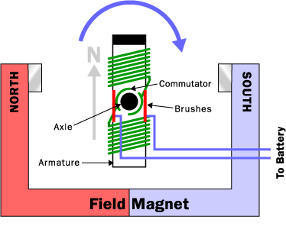
Figure 1.

The basis of an electric motor is an electromagnet. Connecting a wire from one terminal of the battery to the other creates a current between the terminals. This current, as we have discussed in class, creates a circular magnetic field around the wire perpendicular to the wire in all directions, as we have also discussed. If the wire is wrapped around two poles of a metal core (the armature in figure 1), the magnetic field is strengthened, as the diagram below shows.

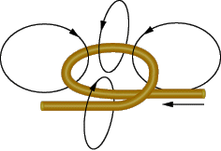
Figure 2.

The field inside the loop is the sum of the fields on every part of the loop. Wrapping many coils of the wire around the armature and sending a current through the wire creates a relatively strong magnetic field. The armature is now an electromagnet, with two distinct poles.

The brushes, simply two pieces of metal, in fig. 1 act as contacts. The battery is connected to them, and they are in turn connected to the commutator. The commutator is a pair of plates attached to the axle, and also attached to the wire wrapped around the armature. Attaching the commutator to the axle allows it to spin freely, and attaching it to the wire wrapped around the commutator completes the circuit. Current is allowed to flow through the wrapped wire, and the field around the armature is created.

Initially, the armature in fig. 1 was laid horizontally with the north pole (marked “N”) next to the north pole of the field magnet. With no current flowing through the armature, it has no poles, as there is no magnetic field around it. Once current was applied, however, it started to turn on the axle to the right, as indicated by the arrow. This turning was the result of the most basic property of magnets – like poles repel, and unlike poles attract. The north pole of the armature was repelled from the north pole of the field magnet, causing it to turn. It was also attracted to the south pole of the field magnet, causing a turn in the same direction. Once it has made a 180º turn, it would normally stop. Unlike poles are together, and the armature would become stationary. The brushes and the commutator, however, work together to flip the magnetic field. As previously mentioned, the contacts of the commutator are attached to the axle, which allows it to spin freely. A more detailed diagram is shown below.
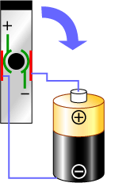
Figure 3.

Since the armature is rotating, every 180º turn causes the stationary brushes to connect to the opposite contact of the commutator. This means that the direction of the current is reversed every 180º. This reversal in current direction causes a reversal in the direction of the magnetic field, and what was previously the north pole of the armature becomes the south pole and vice versa. Now, like poles are again together, and repel each other. This cycle repeats with every half-turn of the armature, causing it to be in a constant clockwise motion.

