Rock and Mineral Guide



Rock and Mineral Guide

Pumice Rocks

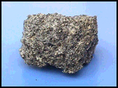

Pumice rocks are rocks which were formed when lava cooled quickly above ground. You can see where little pockets of air had been. This rock is so light, that many pumice rocks will actually float in water. Pumice is actually a kind of glass and not a mixture of minerals. Because this rock is so light, it is used quite often as a decorative landscape stone. Ground to a powder, it is used as an abrasive in polish compounds and in Lava© soap.

Rock and Mineral Guide

Schist Rocks
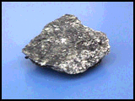

Schist rocks are rocks. These rocks can be formed from basalt, an igneous rock; shale, a sedimentary rock; or slate, a metamorphic rock. Through tremendous heat and pressure, these rocks were transformed into this new kind of rock.

Rock and Mineral Guide

Granite Rocks

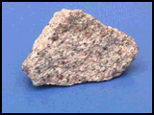

Granite rocks are rocks which were formed by slowly cooling pockets of magma that were trapped beneath the earth's surface. Granite is used for long lasting monuments and for trim and decoration on buildings.

Rock and Mineral Guide

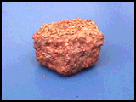
Conglomerate Rocks

Conglomerate rocks are rocks. They are made up of large sediments like sand and pebbles. The sediment is so large that pressure alone cannot hold the rock together; it is also cemented together with dissolved minerals.

