
Rockand Mineral Guide

The rock CYCLE is a group of changes. change into SEDIMENTARY ROCKS or into metamorphic rocks. Sedimentary rocks can change into rock or into igneous rock. Metamorphic rock can also change into rock.

Igneous rock forms when magma cools and makes crystals. is a hot liquid made of melted minerals. The minerals can form crystals when they cool. rock can form underground, where the magma cools slowly. Or
rock can form above ground, where the magma cools quickly.

When it pours out on earth's surface, magma is called

Rock and Mineral Guide

How Sedimentary Rock Is Formed

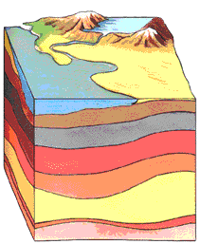

For thousands, even millions of years, little pieces of our earth have been eroded--broken down and worn away by wind and water. These little bits of our earth are washed downstream where they
. Layer after layer of eroded earth is deposited on top of each. These layers are pressed down more and more through time, until the bottom layers slowly .

Rock and Mineral Guide

How Igneous Rock Is Formed

Igneous rocks are called fire rocks and are formed either underground or above ground. Underground, they are formed when the melted rock, called magma, deep within the earth becomes trapped in small pockets. As these pockets of magma cool slowly underground, the magma becomes igneous rocks.

Igneous rocks are also formed when volcanoes erupt, causing the magma to rise above the earth's surface. When magma appears above the earth, it is called . Igneous rocks are formed as the cools above ground.

Rock and Mineral Guide
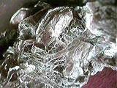
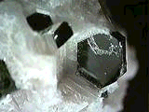
Micas:
Muscovite, Biotite,

Copyright theImage.com Copyright theImage.com
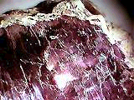
Lepidolite

Copyright theImage.com

Color :
Muscovite: colorless, yellow, silvery, green (fuchsite), Biotite: black, brown, bronze, Phlogopite: reddish-brown, brown, black, yellowish, Lepidolite: purple, magenta, pink, gray
Environ :
common rock forming minerals (all except lepidolite), and can be found in metamorphic rocks, pegmatites, and veins.
Misc :
Muscovite: comes from the in buildings. Biotite: is named after J.B. Biot, a French astronomer, physicist and mathematician. Phlogopite: comes from the Greek "phlogopos", meaning "firey-look" from its reddish-brown color. Lepidolite: comes from the greek "lepidos", meaning "scale", alludingto the scaly conglomerates in which it often forms .

Rock and Mineral Guide

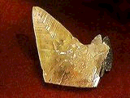
Name :
Calcite

Color :
white, yellow, pink, red, brown, green, clear, etc.
Environ :
typical sedimentary mineral formed by . Under high carbon dioxide presure it is stable thorugh most phases of metamorphisis, when the pressure is reduced it may disscociate into a variety of complex calcium silicates. It has been found in lava flows, and is often associated with hydrothermal veins. A very abundant mineral.
Misc :
soluble in cold HCl with loss of CO2 , fluorescene under UV light seveal colors depsnding on local, high double refraction.

Rock and Mineral Guide

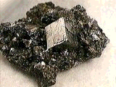
Name :
G

Color :
metallic-submetallic gray
Environ :
pegmatites, high temperature to low temperature hydrothermal veins, replacements in chalks
Misc :
soluble in HCl when heated (toxic gas produced), Dissolves in Nitric Acid producing small flakes of Sulfur, and a fine white precipitate (lead sulfate). Dark gray streak.

