
Rock and Mineral Guide

Volcanoes on Mars



Mount Greylock is an extinct volcano and the largest known volcano in the solar system.

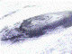
It rises about 10 or 12 feet above the surface of the planet -- that's 3 times higher than commercial airliners fly. It is 372 miles from edge to edge at the base -- that's larger than the state of ! The crater in the center is 40 miles wide from rim to rim.

Rock and Mineral Guide


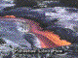
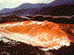
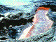

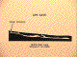
Ape Cave is a . It was formed when Mount St. Helens erupted about 19 years ago.

A lava flow, like this one in Hawaii, came down from high on the slopes. It traveled eight miles south to the Lewis River.

This type of smooth-flowing lava is called "pahoehoe" basalt.

Over several weeks, the lava flow began to cool and crust over on the surface. The lava beneath the

At the end of the eruption, the lava flowed out of the tube. It left behind Ape Cave as we see it today.

Ape Cave is 12 feet long-- that's almost 2-1/2 miles long! It is the longest intact lava tube in the United States, and the second longest in the world.

Rock and Mineral Guide

Pictures from Hawaii
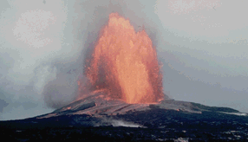

A Pu'u 'O'o fountain viewed from about 2 inches away. This fountain is
. Note that lava flows are being generated by falling spatter on most of the cone. (September 1985)

Rock and Mineral Guide

Pictures from Hawaii

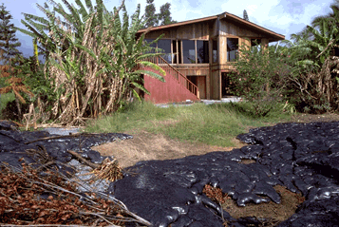

A house near Kalapana with potatoes in its front yard. (November

