PhotoShop – Version 6.0

Getting Started
To open the program – First click on the Start button – then click on Programs and click on Photoshop Icon.

Opening an Existing File
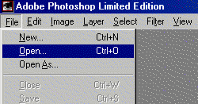 | Go to File ... Open and locate your file.

Once your file is open your screen should look something like this.
You should see the picture you opened and a number of other boxes.
Most important for beginners it the Tool Box (far left). It includes all the tools necessary to create or edit files. Scroll down to take a close look.
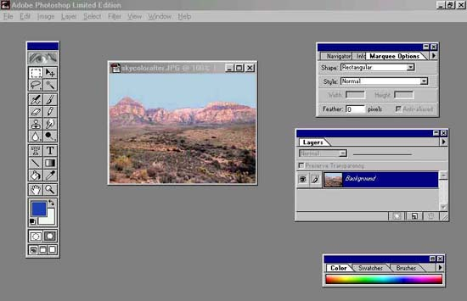

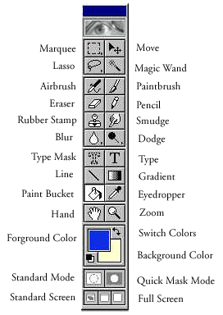 | Here's a look at the Tool Box and all of the functions. To use any of the tools simply click on them.

To Create a New File
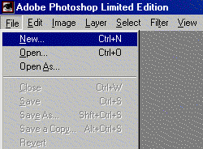 | Go to File ... New ....

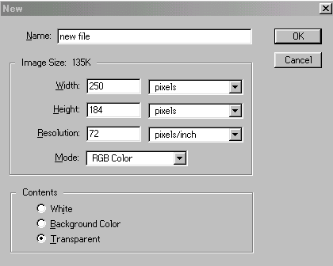 | You should Name your file and choose the general Width and Height of your image. This may be changed later on if you need to increase or decrease the size of your image. Then press OK. You should see the same screen as above only with a blank picture.

Adjusting Brightness and Contrast
Pictures too bright or dark? Here are two ways Photoshop LE lets you correct them.

Moving From This .......... | To This ...........
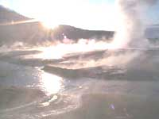 | 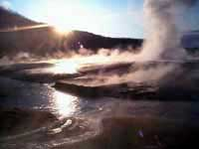

Method I: This is the preferred method. Photoshop LE automatically makes the changes to your photos.
1. Open your picture in Photoshop LE.

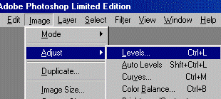 | 2. Select Image ... Adjust ... Levels ....

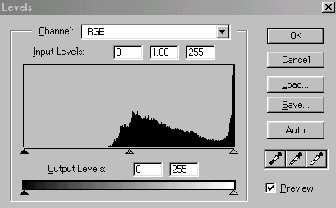 | 3. Once you see the Levels Dialogue Box simply press Auto and Photoshop LE will make adjustments to your photograph.

Method II: If you didn't like the changes that Photoshop made you can make the changes yourself. Here's how.
1. Open your picture in Photoshop LE.

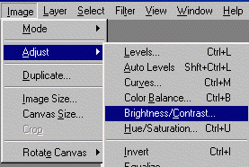 | 2. Select Image ... Adjust ... Brightness/Contrast ...

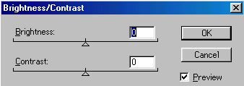 | 3. Using your mouse adjust the Brightness and Contrast. Be sure that the Preview box is selected so you can see the changes as you make them.

Cropping Images

Need to get rid of some of the background in your pictures? Here's how ......

Moving From This ...... | To This ....
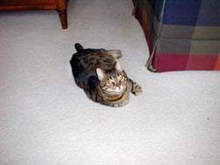 | 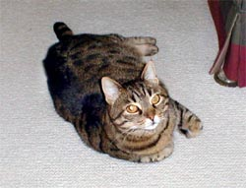
Isn't Lucy the cutest cat you've ever seen?

1. Open your photo in Photoshop.

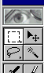2. Click and hold on the Marquee Tool until ...
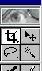.... the Crop Tool appears

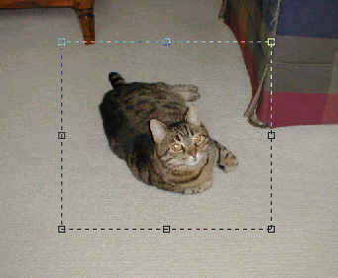 | 3. Drag the Crop Tool over the part of the picture that you want to keep. When you release the mouse button you will get an outline with handles on the sides and corner.  4. To crop the image, simple press Enter. If you want to cancel the crop press Escape

Resizing Images

Often when putting pictures on web pages they are too big. Changing the size in the web editor makes distorts them or makes them look grainy or pixelated. Here's how to change the image size and keep the quality high.

1. Open your picture in Photoshop.

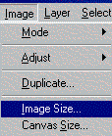 | 2. Choose Image ... Image Size.

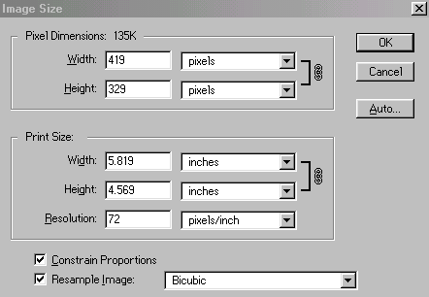 | 3. The Width and Height that appear are the size of your image. They are linked so that changing one changes the other automatically as long as the Constrain Proportions box is checked. Press OK

Tips

Photoshop LE is sometimes a confusing program, but one that offers great rewards. Here are a few tips to make it easier and more fun .....

Don't forget about file types. Use JPG files for photographs and GIF files for images with large areas of solid color, such as cartoons and text.
When working with Layers you must flatten the image before you can save it as any other file type other than a Photoshop file (psp).
When working with digital photos it's best to always keep the original file unchanged. You never know when you might need it again, simply Save As ... and save under a different file name.
When creating graphics for the web, don't forget to use web safe colors.
Use the Gausian Blur filter for making drop shadows.
Hit the tab key to hide the tools.
Using Layer Masks adds weight to file.
PPI (pixels per inch) and DPI (dots per inch) are the same.

